

Advanced Programming Lab 2

Assignment

Suryanshu

22BCS12106

605 - B

Question 1

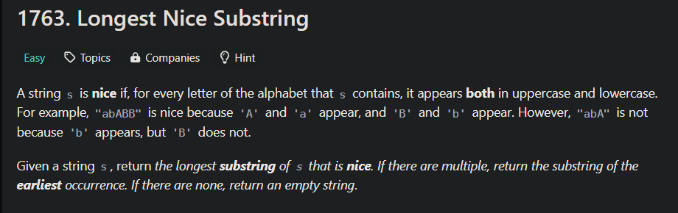

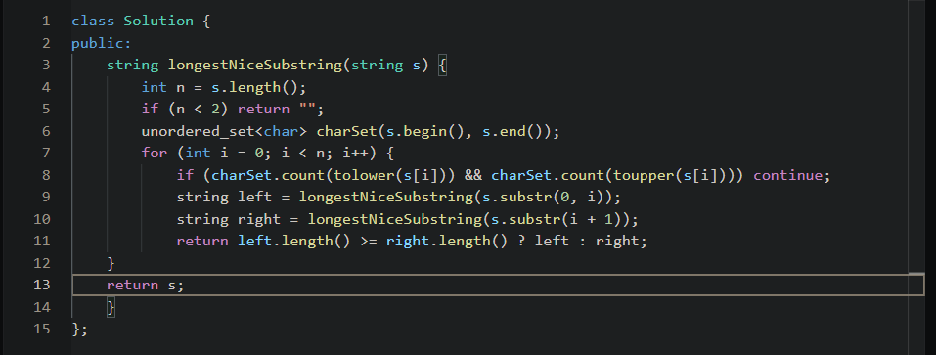

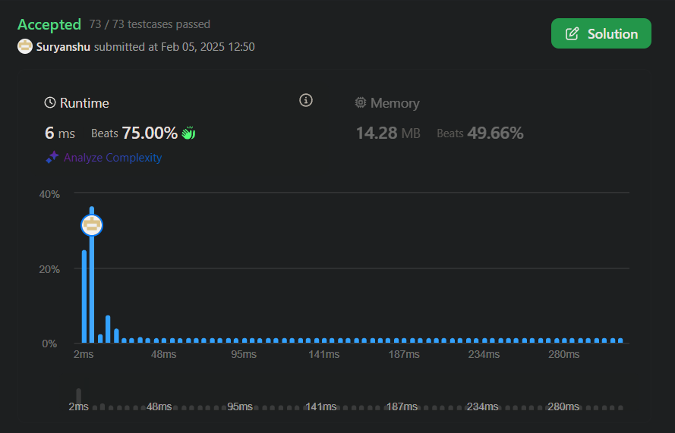

Question 2

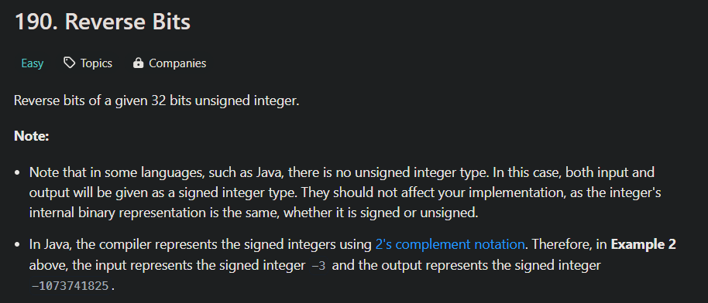

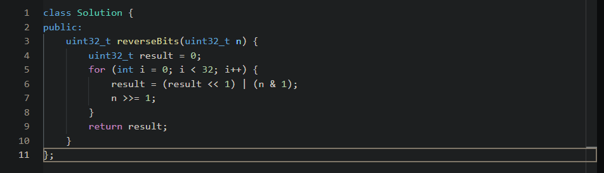

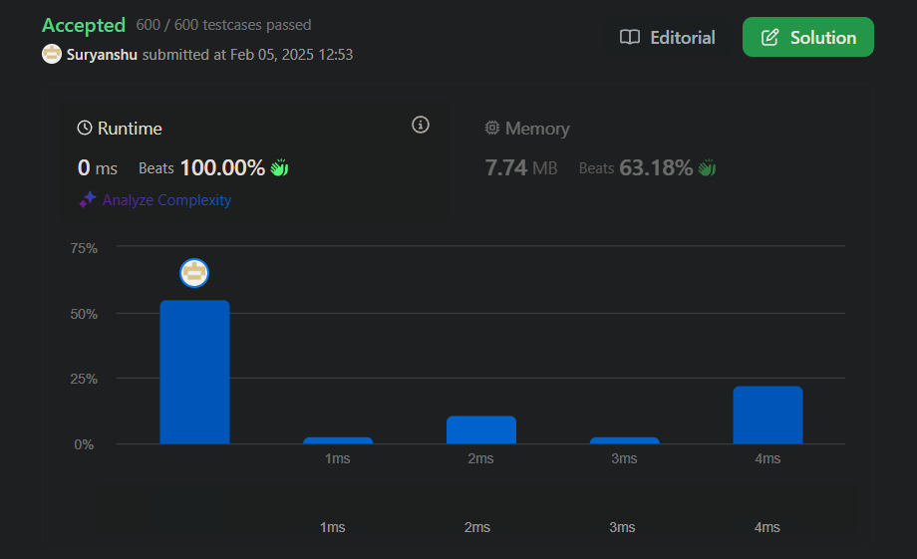

Question 3

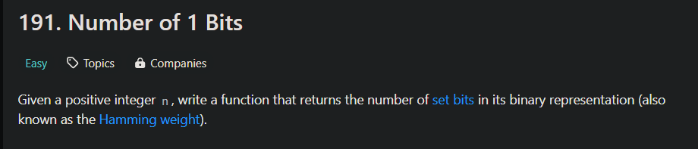

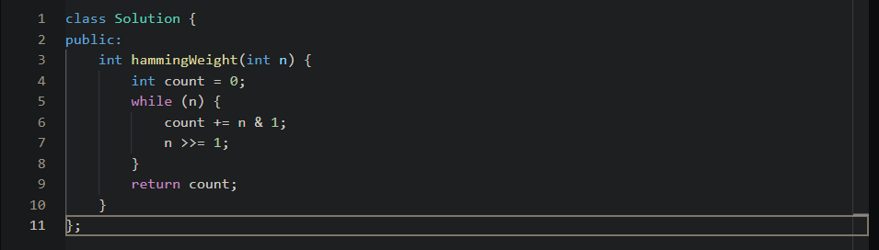

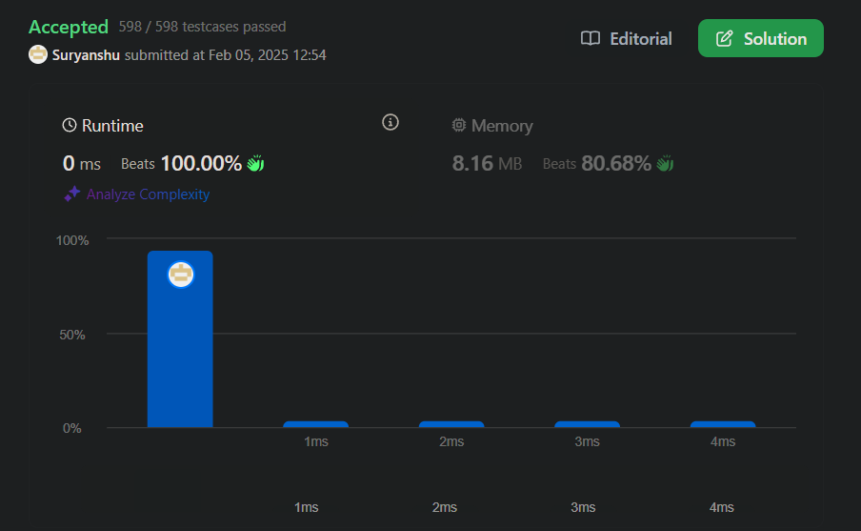

Question 4



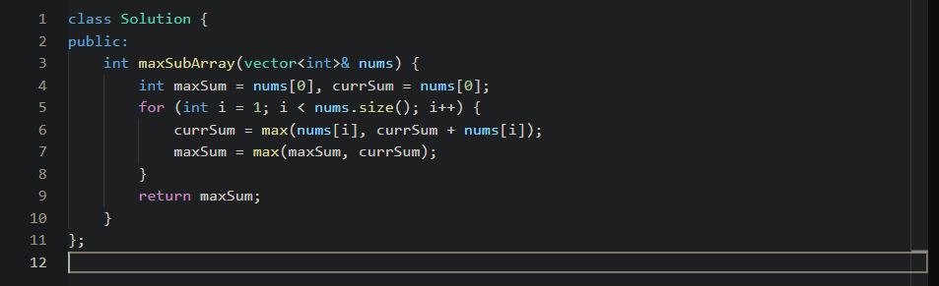

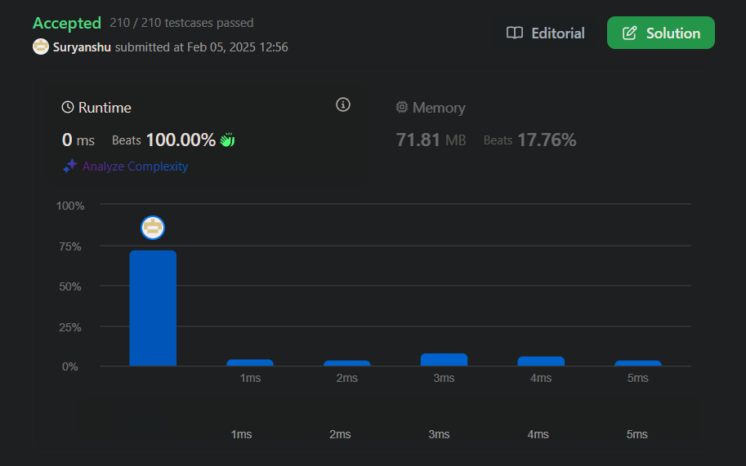

Question 5

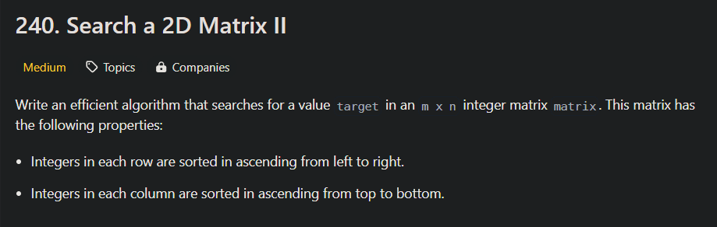

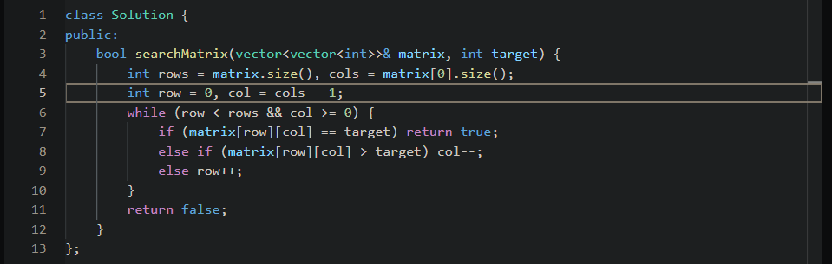

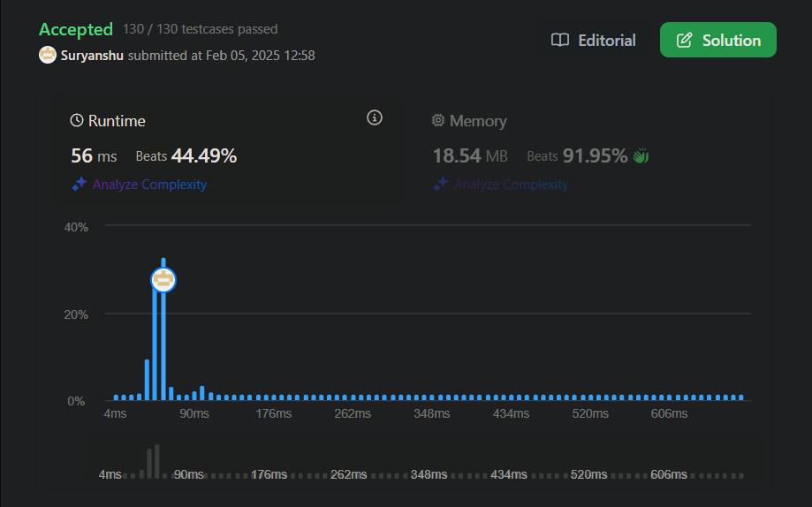

Question 6

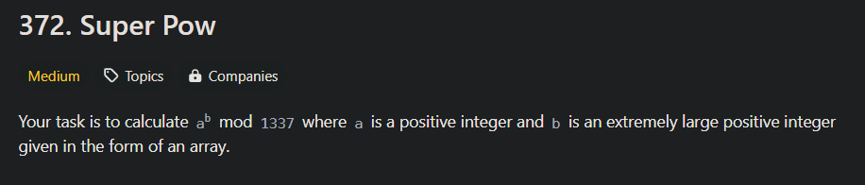

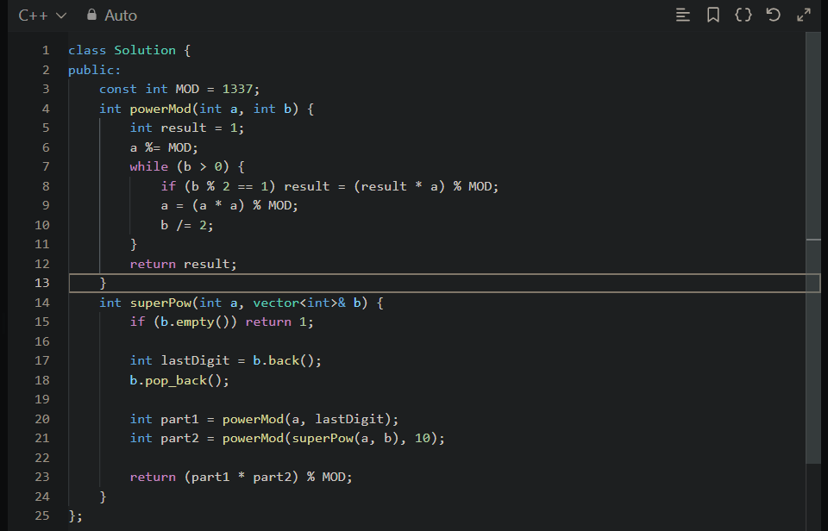

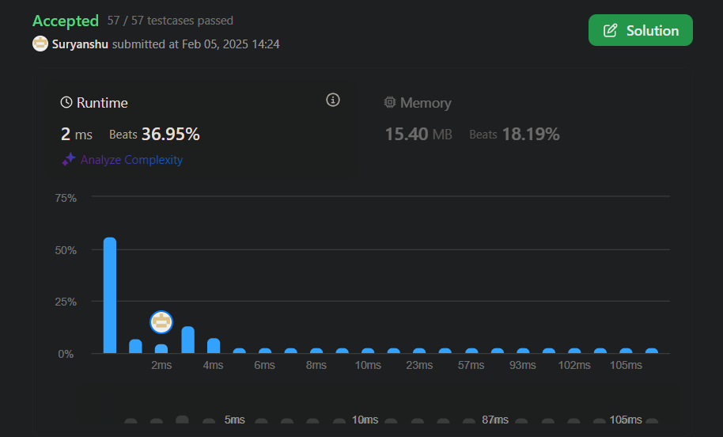

Question 7

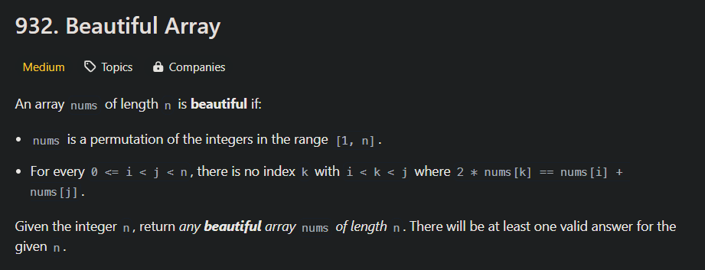

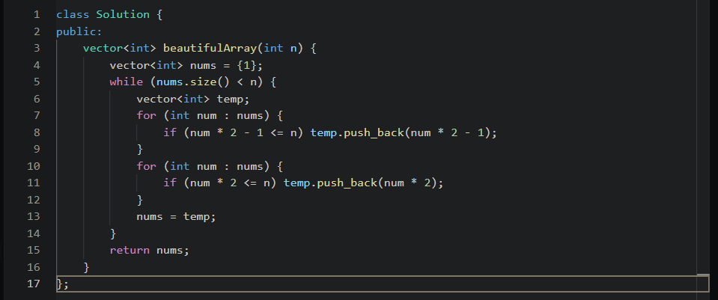



Question 8

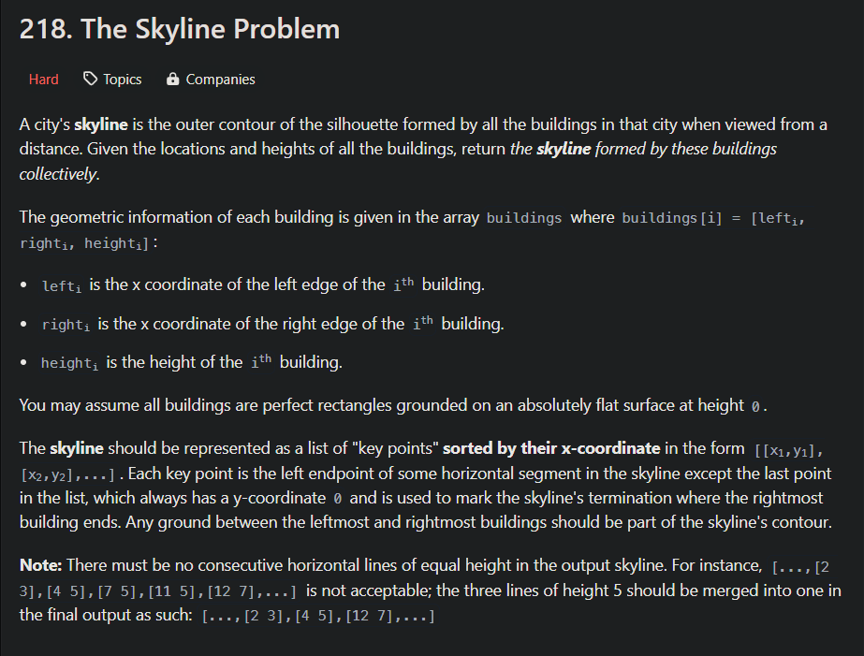

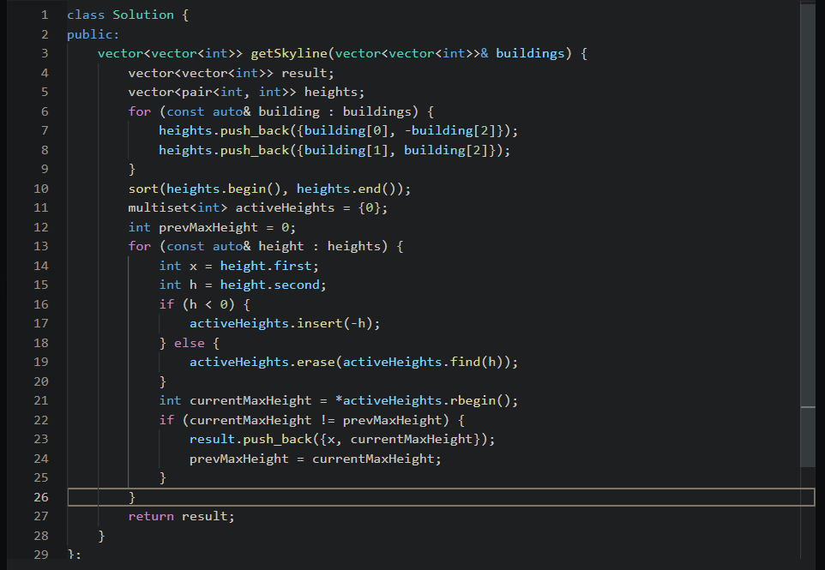

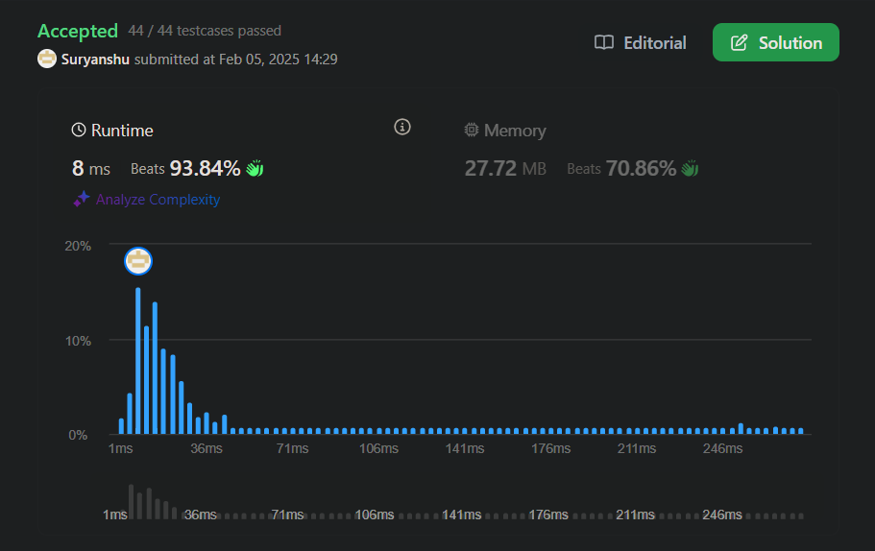

Question 9

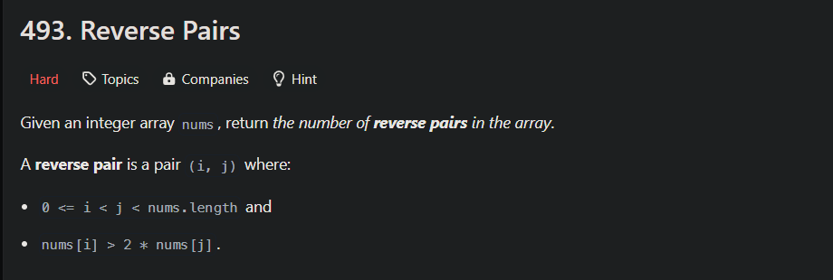

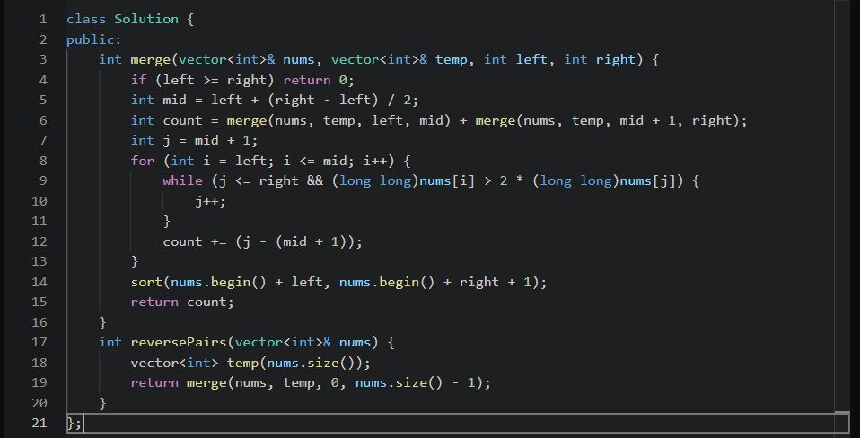

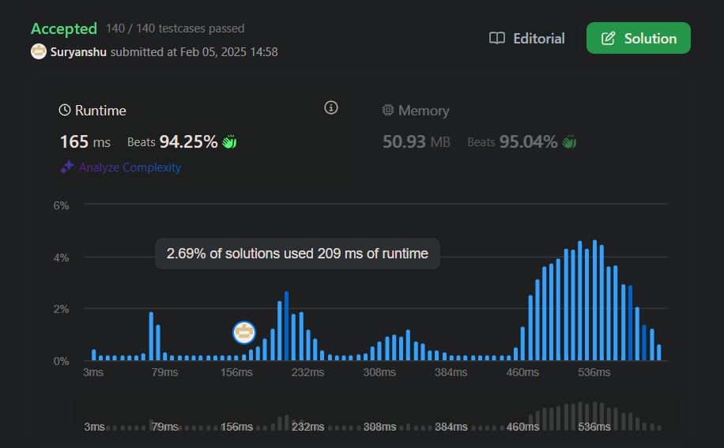

Question 10

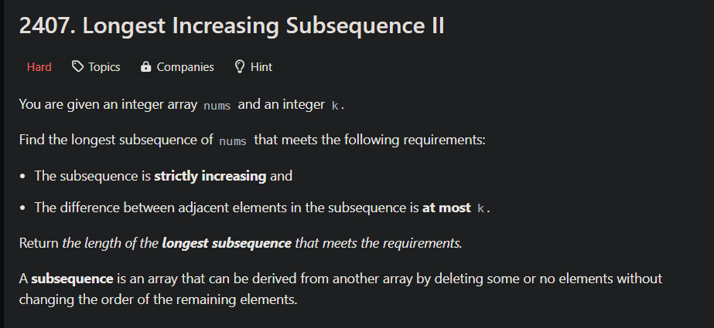

class Solution {

public:

    vector<int> seg;

    void upd(int ind, int val, int x, int lx, int rx) {

        if(lx == rx) {

            seg[x] = val;

            return;

        }

        int mid = lx + (rx - lx) / 2;

        if(ind <= mid)

            upd(ind, val, 2 \* x + 1, lx, mid);

        else

            upd(ind, val, 2 \* x + 2, mid + 1, rx);

        seg[x] = max(seg[2 \* x + 1], seg[2 \* x + 2]);

    }

    int query(int l, int r, int x, int lx, int rx) {

        if(lx > r or rx < l) return 0;

        if(lx >= l and rx <= r) return seg[x];

        int mid = lx + (rx - lx) / 2;

        return max(query(l, r, 2 \* x + 1, lx, mid), query(l, r, 2 \* x + 2, mid + 1, rx));

    }

    int lengthOfLIS(vector<int>& nums, int k) {

        int x = 1;

        while(x <= 200000) x \*= 2;

        seg.resize(2 \* x, 0);

        int res = 1;

        for(int i = 0; i < nums.size(); ++i) {

            int left = max(1, nums[i] - k), right = nums[i] - 1;

            int q = query(left, right, 0, 0, x - 1);

            res = max(res, q + 1);

            upd(nums[i], q + 1, 0, 0, x - 1);

        }

        return res;

    }

};

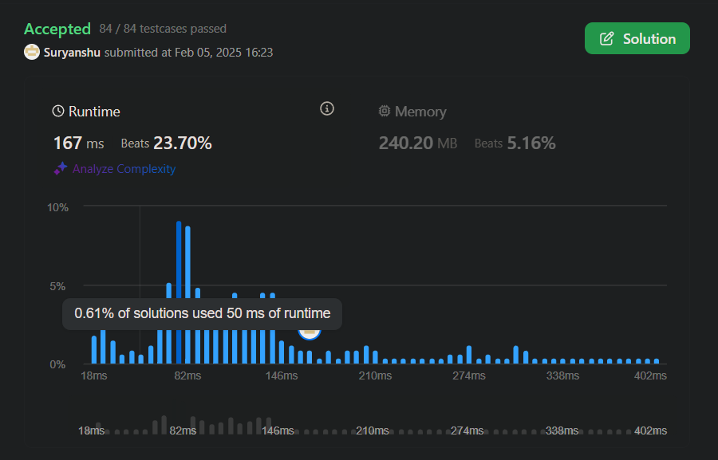

Question 11

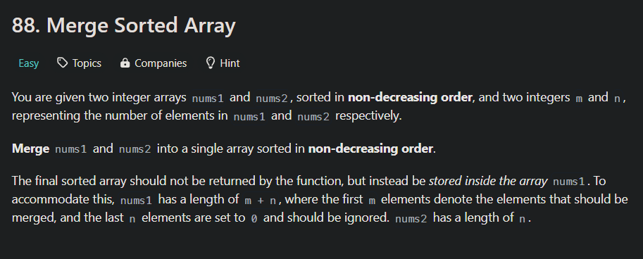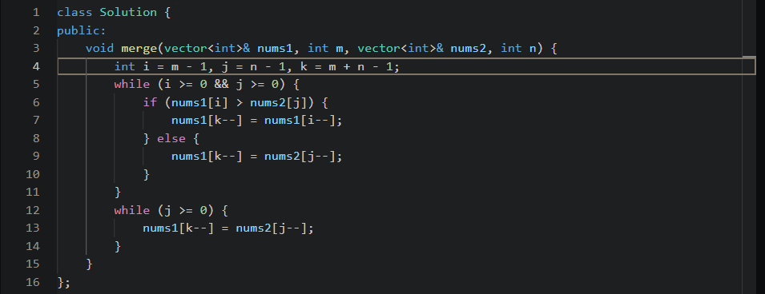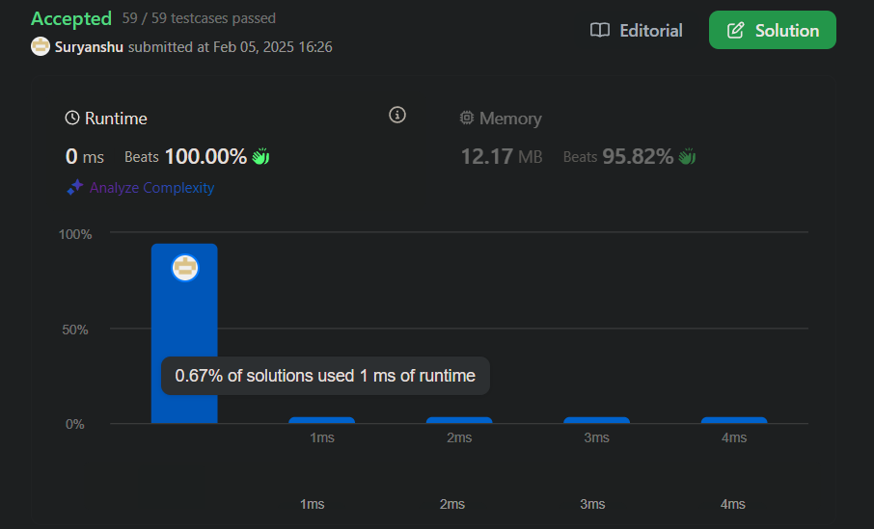

Question 12

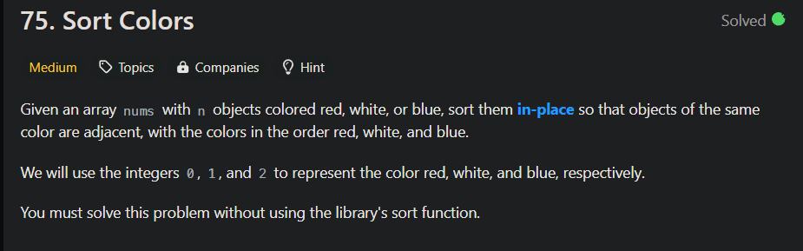

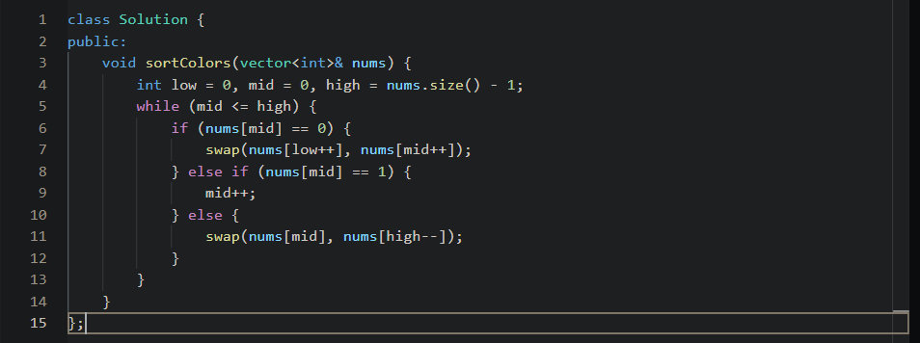

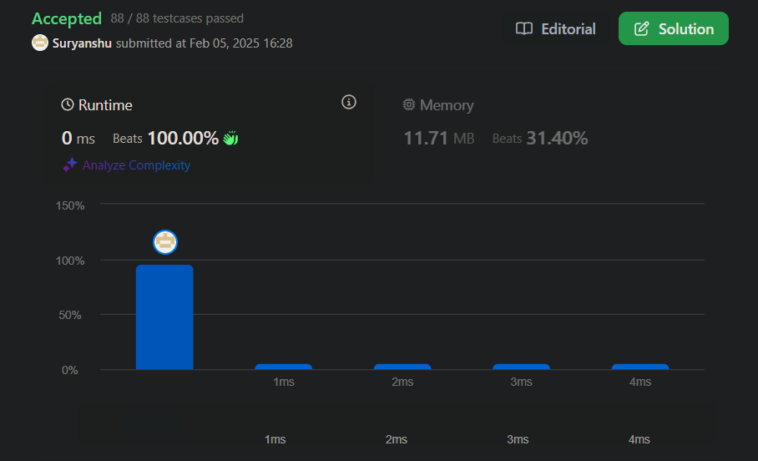

Question 13

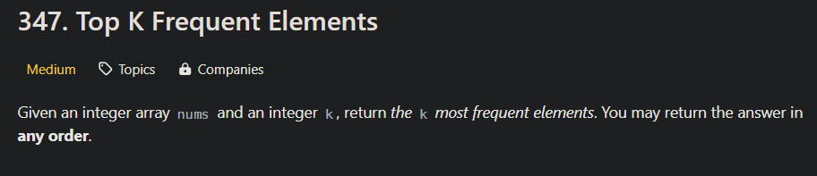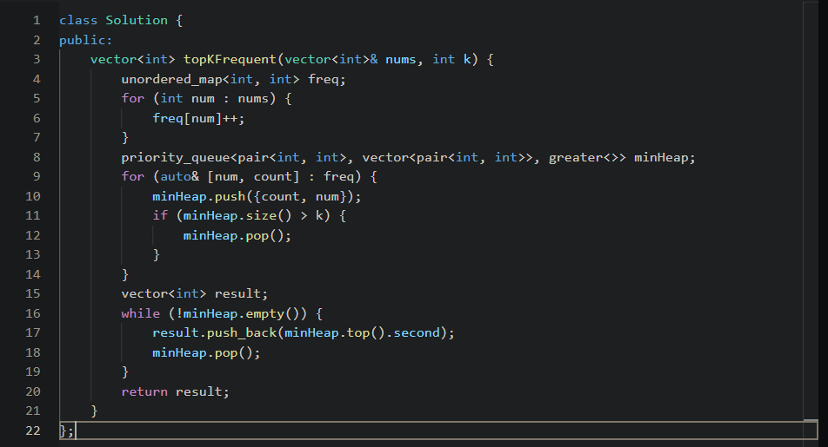

Question 14

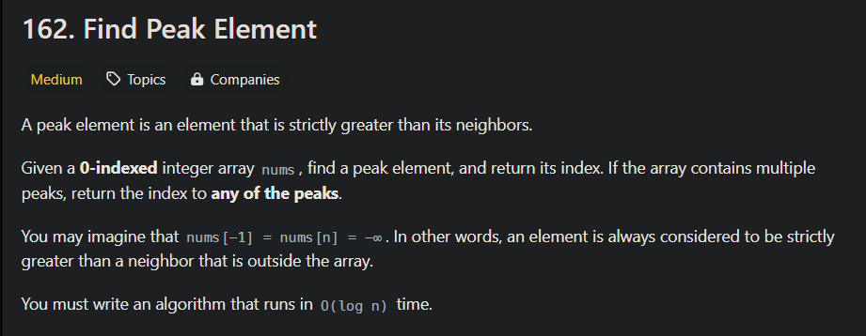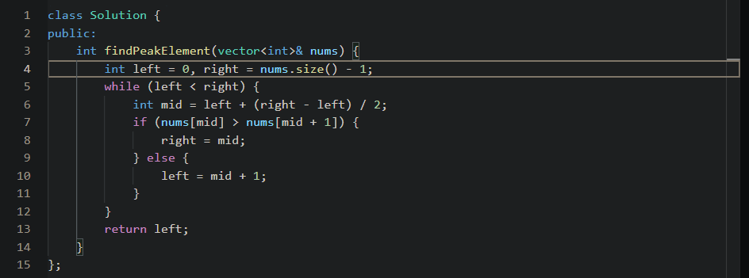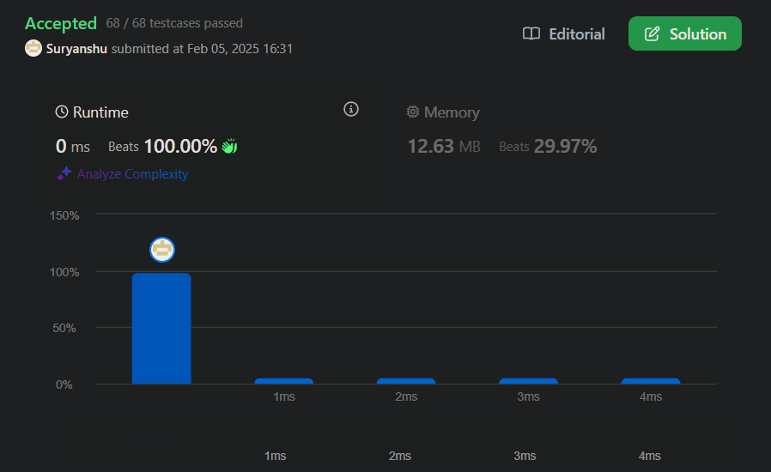

Question 15

